Lecture 8
Essential and Non-essential Amino Acids
Essential amino acids (EAA) are those amino acids that cannot be synthesized by the human body, and therefore have to be supply by the diet. EAA are also known as indispensable amino acids. On the other hand, those amino acids that can be synthesized by the body are called non-essential amino acids (dispensable amino acids). Out of the 20 common amino acids, 9 are essential while the other 11 are non-essential. Daily adult intake of amino acids is approximately 0.8g/Kg.
This will be higher for a child or pregnant woman. Animal proteins are often low in certain important amino acids e.g methionine and lysine.
Legumes are low in methionine. Grains are low in lysine. Corn is low in tryptophan and lysine. Dietary proteins cannot be absorbed directly from the intestine. They must be hydrolyzed by a group of enzymes (proteases and peptidases) to amino acids.

Table: Essential and non-essential amino acids.
Essential | Non-essential
Histidine | Alanine
Isoleucine | Arginine
Leucine | Aspartate
Lysine | Asparagine
Methionine | Cysteine
Phenylalanine | Glutamate
Threonine | Glutamine
Tryptophan | Glycine
Valine | Proline
 | Serine
 | Tyrosine
*Arginine, cysteine, and tyrosine are considered to be "conditional essential”
*Some adults can synthesize histidine on their own

R Groups and the Chemical Properties of Amino Acids
The charged functional groups of some amino acids ensure that they are readily soluble in polar solvents such as water and ethanol but insoluble in nonpolar solvents such as benzene or ether. Similarly, the high amount of energy required to disrupt the ionic forces that stabilize the crystal lattice account for the high melting poits of amino acids. Amino acids do not absorb visible light and are therefore colourless. However, Tyr,Phe and Trp absorb high wavelength UV light. They contribute majorly to the ability of most proteins to absorb light in the region of 280nm. The respective R groups of amino acids determine their properties e.g the hydrophobic R groups of Ala, Val, Leu and Ileu as well as the aromatic R groups of Phe, Tyr and Trp typically occur in the interior of cytosolic proteins. The charged R groups of basic and acidic amino acids stabilise specific protein conformation via ionic interactions or salt bonds. Each functional group of an amino acid exhibits all its characteristic chemical reactions. For carboxylic acid groups, such reactions include formation of esters, amides and acid anhydrides while those for amino groups include acylation, amidation and esterification.
Optical activity - In all amino acids, α-carbon atom is asymmetric (4 different groups) with exception of glycine. Hence, they exhibit optical activity and they rotate the plane-polarized light to the right or left. As a result, they exist in two optical isomers, D (+) or L (-); D-isomer occurs when amino group is on the right whereas L-isomer occurs when amino group is on the left. The D and L isomers are mirror images of each other. In nature L-amino acids are more common and therefore called Natural amino acids. All amino acids found in proteins are of the L-configuration.
Asymmetry - most amino acids have one asymmetric carbon atom. Two amino acids Threonine and Isoleucine have 2 asymmetric carbon and therefore have 4 optical isomers (2^{n} = 2² = 2x2 = 4).
D-amino acids that occur naturally include free D-serine and D-aspartate in brain tissue, D-alanine and D-glutamate in the cell walls of gram positive bacteria and D-amino acids in some non-mammalian peptides and certain antibiotics.
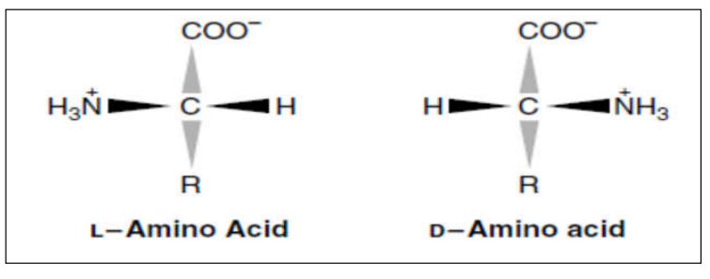
Figure d: L and D isomers of amino acids.

Many proteins also contain derived amino acids, which are usually formed by enzymatic modification of an amino acid after it has been incorporated into a protein. For example, collagen contains hydroxyproline (the –OH group serves to stabilize the collagen fibre).
Prothrombin, a clotting protein contains γ-carboxyglutamate. Defective carboxylation of glutamate in this protein may lead to haemorrhage. The action of some hormones is also mediated by phosphorylation and dephosphorylation of specific serine residues in a variety of proteins.

Acid Base Properties of Amino Acids
Ampholytes or Amphoteric Nature of Amino acids - All amino acids contain at least two ionizable groups the α-amino group and the α-carboxyllic group, some contain an additional acidic or basic group in their side chain, which are responsible for the amino acids, acid- base behaviour. As a result of their ionizability the following equilibrium reaction can be written;

R-COOH ↔ R-COO⁻ + H⁺
R-NH₂ ↔ R-NH₃⁺

Since the above reactions are reversible this indicates that amino acids can act as acids (as demonstrated by the forward reaction) or as bases (as demonstrated by the reverse reaction). Thus compounds with such behavior are called Ampholytes or Amphoteric compounds. They are capable of donating or accepting protons.

Zwitterions - Amino acids behave as Zwitterions. A zwitterion is a dipolar ion containing negative and positive charges. All neutral amino acids are present in the Zwitterions form. At physiological pH (around 7.4) the carboxyl group will be unprotonated and the amino group will be protonated.

pI of Amino Acids
The net charge on an amino acid i.e the sum of all the +vely and –vely charged groups present depend on the pK values of its functional groups and the pH of the surrounding medium. Altering the charge on amino acids and their derivatives by varying the pH facilitates the physical separation of amino acids, peptides and proteins. The isoelectric pH, called the pI is the pH midway between pK values on either side of the isoelectric species. For an amino acid such as alanine that has only 2 ionisable groups, the isoelectric pH is
pI= Pk1 + pK2/2= 2.35+ 9.69/2= 6.02
For polyfunctional acids, pI is the pH midway between the pka values on either side of the isoionic species e.g for aspartic acid, pI = 2.09+
3.96/2, = 3.20

Table: pKa and pI values of amino acids.
pKa1= α-carboxyl group, pKa2 = α-ammonium ion, and pKa3 = side chain group.
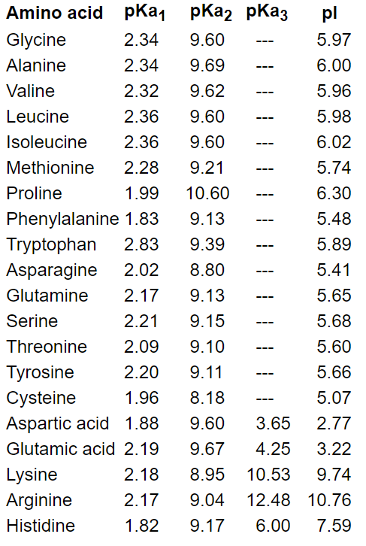

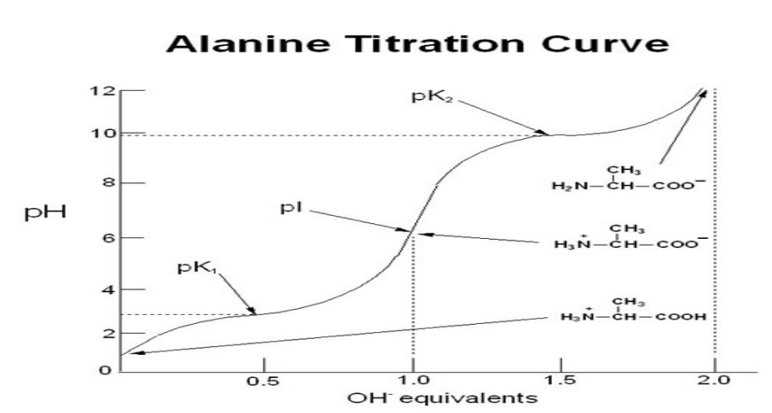

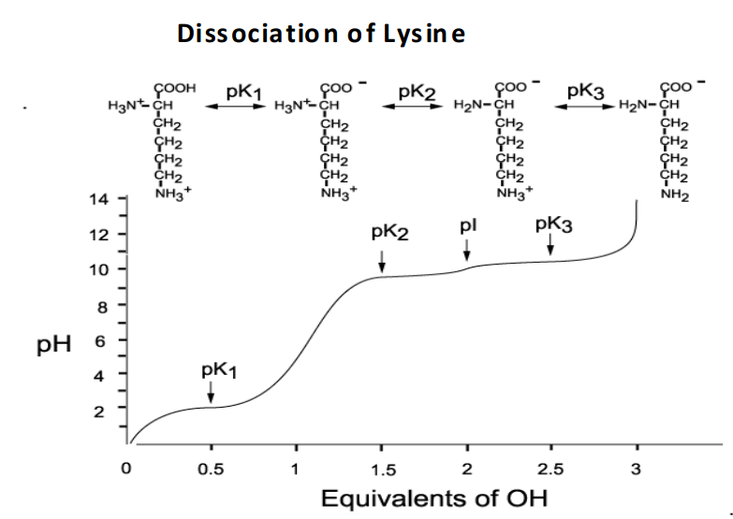

Figure e: Determination of Isoelectric Point of Ala and Lys.

Formation of Peptide Bonds
The most important reaction of amino acids is the formation of a peptide bond. This involves the joining of the α- carboxyl group of one amino acid to the α- amino group of another amino acid, with resultant loss of a water molecule. The biosynthesis of peptide bonds requires an input of free energy, whereas their hydrolysis is thermodynamically favourable.
Many amino acids (usually > 100) are joined by peptide bonds to form a polypeptide chain.

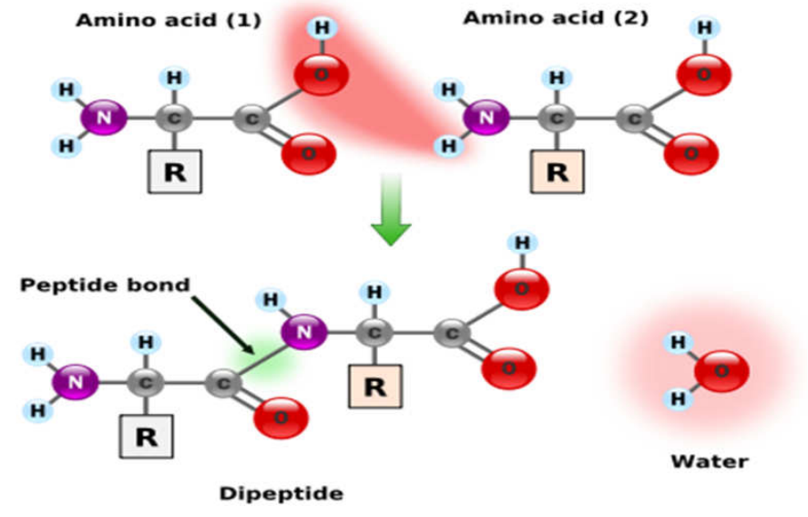

Figure f: Formation of Peptide Bond.

An amino acid unit in a polypeptide is called a residue. A PP chain has different ends- the α-amino and the α- carboxyl groups. The amino end is taken to be the beginning of the chain e.g in the tripeptide ala-gly-trp, alanine is the amino-terminal residue and trp is the carboxyl terminal residue. A PP chain consists of a regularly repeating part, called the main chain (also called the backbone), and a variable part comprising the distinctive side chains. In some proteins, a few side chains are cross-linked by disulfide bonds. These cross links are formed by the oxidation of cysteine residues. The resulting disulfide is called cystine. Amino acids present in peptides are called aminoacyl residues and are named by replacing the-ate or –ine suffix of free a.as with ---yle.g aspartyl, alanyl etc. Peptides are then named as derivatives of the carboxyl terminal aminoacyl residue e.g Lys-Leu-Tyr-Gln is called Lysyl-Leucyl-Tyrosyl-Glutamine. This indicates that the α- carboxyl group of glutamine is not involved in peptide bond formation.
Many proteins consist of a single polypeptide chain e.g myoglobin. Others contain 2 or more chains which may be either identical or different e.g Hemoglobin is made up of 2 chains of one kind and 2 of another kind of pp chain (α and β) , held together by non-covalent forces. The PP chains of some multi-chain proteins are linked by disulfide bonds e.g insulin.

